Color Theory Graphics and Images in Multimedia

What Is Color Theory?
Color theory is a set of principles used to understand how colors interact, combine, and affect human perception. It provides guidelines for selecting color combinations that are visually appealing and functionally effective in conveying messages.
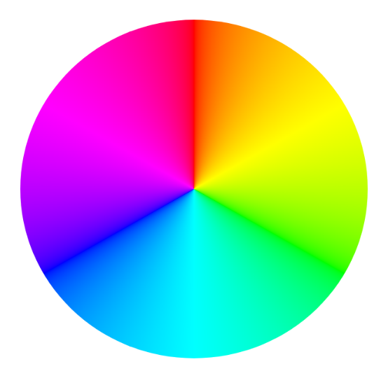
The Color Wheel
The color wheel is a circular diagram that maps the visual spectrum of colors to show their relationships and how they can be combined. First developed by Sir Isaac Newton in 1666, it serves as the foundational tool for color theory, helping artists, designers, and decorators choose harmonious color palettes.
Key Components of the Color Wheel
Primary Colors
- Red, Blue, Yellow
These are the base colors that cannot be created by mixing others.
Secondary Colors
- Green, Orange, Purple
Formed by mixing primary colors.
Tertiary Colors
- Created by mixing primary and secondary colors (e.g., blue-green, red-orange)
Color Models in Multimedia
In multimedia, a color model is a mathematical system that describes how colors can be represented as tuples of numbers. Because multimedia content is consumed across various devices—from smartphone screens to high-end printers—different models are used depending on whether you are working with light or pigment.

1. RGB (Red, Green, Blue) – The Additive Model
The RGB model is the foundation of all digital multimedia. It is called an "additive" model because it starts with darkness (black) and adds light together to create color.
- Primary Colors: Red, Green, and Blue light.
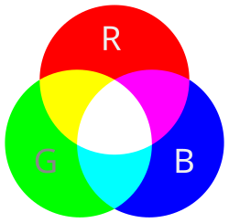
- Mixing: When all three are combined at full intensity ($255, 255, 255$), they create White.
- Applications: Digital cameras, scanners, computer monitors, smartphone screens, and LED displays.
- Format: Often represented in Hexadecimal (e.g., #FFFFFF for white) or Decimal (e.g., rgb(255, 255, 255)).

2. CMY/CMYK (Cyan, Magenta, Yellow, Black)
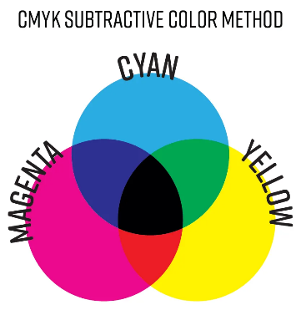
CMYK is used for physical media. It is a "subtractive" model because it starts with white (usually paper) and uses ink to subtract (absorb) wavelengths of light.
- Primary Colors: Cyan, Magenta, and Yellow.
- The "K" (Key): Theoretically, mixing C, M, and Y creates black, but in practice, it creates a muddy brown. Pure Black (Key) is added for depth and to save on ink costs.
- Applications: Offset printing, home inkjets, brochures, and physical magazines.
- Multimedia Note: If you are designing a graphic for the web, you must convert it from CMYK to RGB to ensure the colors don't appear dull on screen.
There are many more beyond this those are
- HSL and HSV – The Human-Centric Models
- UV and YCbCr – The Video Models
- Color Gamut and Profiles
Color Harmony
Color harmony is the art and science of combining colors in a way that is visually appealing and balanced. In multimedia, harmony ensures that graphics and images don't overwhelm the viewer, but instead create a specific mood or guide the user's focus.
These harmonies are based on the geometric relationships between colors on the Color Wheel.
1. Complementary Harmony
Complementary colors sit directly across from each other on the color wheel (e.g., Blue and Orange or Red and Green).
- Effect: High contrast and high energy.
- Multimedia Use: Excellent for "Call to Action" (CTA) buttons or highlighting critical information. Because the contrast is so sharp, it makes elements "pop" against a background.
2. Analogous Harmony
Analogous colors are groups of three colors that are next to each other (e.g., Blue, Blue-Green, and Green).
- Effect: Serene and comfortable. These palettes are often found in nature and are naturally pleasing to the eye.
- Multimedia Use: Ideal for background gradients, website themes, or atmospheric lighting in video production where a unified, calm look is desired.
3. Triadic Harmony
A triadic scheme uses three colors that are equally spaced around the color wheel, forming a triangle (e.g., Purple, Green, and Orange).
- Effect: Vibrant and balanced. Even if the colors are pale or desaturated, this scheme maintains a lively feel.
- Multimedia Use: Popular in character design, animations, and icons where you need variety without one single color dominating too aggressively.
4. Split-Complementary Harmony
This is a variation of the complementary scheme. It uses a base color and the two colors adjacent to its complement.
- Effect: High contrast like the complementary scheme, but with less visual tension and more variety.
- Multimedia Use: Often used by designers who want the "pop" of contrast but want a more sophisticated and less "aggressive" palette.

5. Monochromatic Harmony
This uses different values (tints, tones, and shades) of a single hue.
- Effect: Clean, elegant, and highly organized.
- Multimedia Use: Frequently used in "Dark Mode" UI designs or minimalist portfolios. It ensures that the content (text and images) remains the primary focus while the color provides a subtle supporting structure.
The "60-30-10" Rule in Multimedia
To apply these harmonies effectively, designers often use the 60-30-10 rule to maintain balance:
- 60% Primary Color: Usually a neutral or a dominant brand color (the background).
- 30% Secondary Color: A supporting color that provides contrast (headers, sidebars).
- 10% Accent Color: A bold color used sparingly for the most important elements (buttons, alerts).
Psychological Effects of Color
Colors have strong psychological associations that influence audience perception:
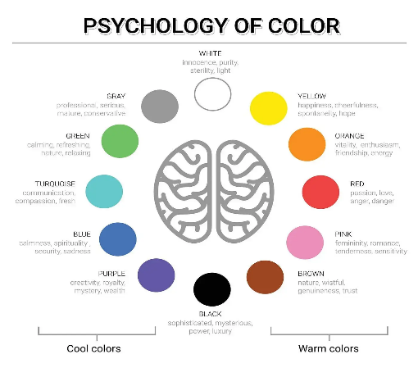
- Red: Energy, passion, urgency
- Blue: Trust, calmness, professionalism
- Green: Nature, growth, health
- Yellow: Happiness, attention, warmth
- Black: Elegance, power, mystery
- White: Purity, simplicity, cleanliness
In multimedia, choosing the right color can reinforce branding and messaging.
Use of Color in Graphics
In graphic design, color is used to:
- Highlight important elements
- Create contrast and readability
- Guide the viewer’s attention
- Establish brand identity
Use of Color in Images and Multimedia Content
In multimedia (videos, animations, interactive media), color plays several roles:
1. Storytelling
Color grading in videos can set the mood—warm tones for happiness, cool tones for sadness or tension.
2. Visual Consistency
Maintaining a consistent color palette ensures a unified look across media elements.
3. Depth and Realism
Shadows, highlights, and gradients add realism and dimension to images.
4. Accessibility
Proper contrast and color choices ensure content is readable for users with visual impairments, including color blindness.

Best Practices for Using Color in Multimedia
- Use a limited color palette (3–5 main colors)
- Ensure strong contrast between text and background
- Maintain consistency across all media elements
- Test colors on different screens and devices
- Consider cultural meanings of colors
- Design with accessibility in mind

Conclusion
Color theory is a fundamental aspect of multimedia design that goes beyond aesthetics. It influences how audiences interpret, feel, and interact with visual content. By understanding color relationships, psychological effects, and technical applications, designers can create compelling graphics and images that effectively communicate their intended message.
Mastering color theory not only enhances visual appeal but also ensures clarity, consistency, and impact in multimedia projects.

